**Assignment 24.4**

**Problem Statement:**

1. Write a hive query find the average age of male and female persons died in the titanic tragedy.

2. Write a hive query to find the number of people died and survived in each class.

**Input:**

You can download the data set from the below link:

<https://drive.google.com/file/d/0ByJLBTmJojjzNmV0dk1EMmwwQ1U/view?usp=drive_web>

**DATA SET DESCRIPTION:**

Column 1 : PassengerId

Column 2 : Survived (survived=0 & died=1)

Column 3 : Pclass

Column 4 : Name

Column 5 : Sex

Column 6 : Age

Column 7 : SibSp

Column 8 : Parch

Column 9 : Ticket

Column 10 : Fare

Column 11 : Cabin

Column 12 : Embarked

**Problem 1:**

**Write a hive query find the average age of male and female persons died in the titanic tragedy.**

**Output:**

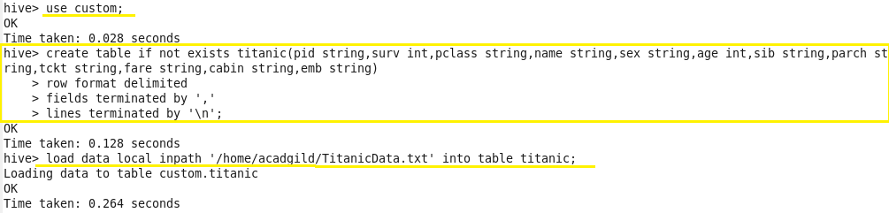

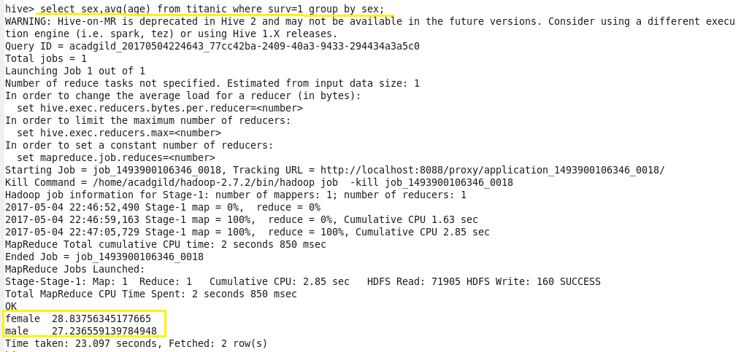

**Problem 2:**

**Write a hive query to find the number of people died and survived in each class.**

**Output:**

